**SIEBEL FORECAST**

**Version: 1.1**

**By**

**SIEBEL Team**

Revision History

|  |  |  |  |  |
| --- | --- | --- | --- | --- |
| **Version No.** | **Issue date** | **Name of the creator/modifier** | **Description of Changes** | **Location (Page, Para / Sec. Nos)** |
| 1.0 | 01/03/2011 | Angira Sinha | Initial Release | New document |
| 1.1 | 04/05/2011 | Angira Sinha | Added more information, Participant Forecast job level details. |  |

**Table of Contents**

High Level Overview 3

Project Description 3

Project Benefits 3

ETL Design 3

Source Tables 3

Target Tables 3

ETL Load 3

Control Tables 3

Source Query 3

List of jobs 3

High Level Data Flow 3

Submitted and Rollup Forecasts 3

Example of Rollup calculation 3

8 level Territory Hierarchy 3

House Account 3

House Account Calculation Example 3

Valid Forecast Flag 3

Job Details 3

Incremental Load 3

Appendix 3

Table Structure 3

References 3

## 

## High Level Overview

Sales Bookings Forecast is entered by the Sales Field in Siebel CE (**C**ustomer **E**dge) at different levels (Sales Rep, Team, District, Region, Multi-Region, Area, Multi-Area, Geo and Worldwide). It is required to **integrate eBI with Forecast in Siebel at ALL Levels** so that meaningful analytics can be performed on forecast data.

Forecast was currently pulled from SMART in eBI. This information was currently available at Sales Area level. This provided visibility only to the WW, Geo and Area level Forecasts (Weekly/Monthly/Quarterly). Using the data from SMART and leveraging existing processes for Forecast hinders eBI in providing meaningful forecast related **trending capabilities** to the users.

### *Project Description*

The objective of this project is to enable eBI to pull Forecast at all levels from Siebel and provide useful metrics to sales users using this information. It will be required to enhance some of the existing dashboards once this data becomes available in eBI.

### *Project Benefits*

* This project will enable a true parallel run between SMART and Siebel Forecast.
* This would enable eBI to change the source of forecast from SMART to Siebel and thereby reduce manual effort required towards maintenance and support of the manual process that provides the forecast in SMART.
* Last, but not the least, this project will help eliminate the manual efforts required by the Geos in submitting their forecast on a spreadsheet.

**This project was released in 2 phases** –

1. Siebel Forecast Phase I

2. Siebel Dot Release – Enhancement based on business requirement and FY11 history load was done in this release.

*P.N – FY11 History load was again done as part of a change request after DIMS.SALES_TERRITORY_TV and DIMS.SALES_TERRITORY_HIERARCHY fix.*

## 

## ETL Design

In Siebel Forecast Phase I, the entire design was encapsulated to bring the forecasts from source into eBI.

### *Source Tables*

* SIEBEL.S_USER
* SIEBEL.S_POSTN
* SIEBEL.S_BU
* SIEBEL.S_PERIOD
* SIEBEL.S_ORG_EXT
* SIEBEL.S_FCST - **Main driving table**
* SIEBEL.S_FCSTSER_DATE
* SIEBEL.S_FCSTSER
* SIEBEL.S_FCST_FCSTITEM
* SIEBEL.S_FCST_ITEM_DTL

### *Target Tables*

Below are the Fact Tables related to Siebel Forecast in EDWNI –

* **FACTS.SALES_PARTICIPANT_FORECAST** – captures Sales Rep forecasts.
* **FACTS.SALES_TERRITORY_FORECAST_SB –** captures 8 level Territory (Team, District, Region, Multi-Region, Area, Multi-Area, Geo, and Worldwide) forecasts.

### *ETL Load*

Data gets loaded in the fact tables from source using two processes –

* Daily Incremental – 9.30 PM PST daily.
* 2 hour refresh Incremental – (6.00 AM, 8.00 AM, 10.00 AM, 12.00 PM and 2.00 PM PST) on Monday and Thursday.

For Daily Incremental, we used the Standard eBI process in ETL i.e. Source to Stage, Stage to Work and Work to EDW. Siebel Replica (**R1SIEB7**) is used to extract data from source.

For 2 Hour refresh Incremental, Siebel Live production instance (**PSIEB7**) is used in ETL to execute the incremental query directly in Source.

### *Control Tables*

* ETL.SIEBEL_FORECAST_FCST_MAX_LUD – Extraction control table used to fetch incremental data.

*P.N – This control table doesn’t get updated during 2 hour refresh incremental load. It only gets updated during daily incremental load with the below value:*

*SELECT max(Last_Upd) AS Last_Upd FROM STG_SIEBEL.S_FCST*

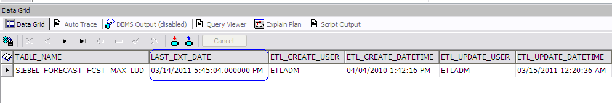

* ETL.EDWNI_REFRESH_CTL – This control table is used to display REFRESH_DATE in the dashboard.

*P.N – This table is not used for reporting purpose now.*

### *Source Query*

Find the source queries attached –





* Filtering by position Type = ‘SR’ in source gives Rep Level forecasts.
* Filter by position Type in ('WW','DM','AD','RD','VP') in source gives Territory level forecasts.

### *List of jobs*

Find the list of jobs and sequences in the attached spreadsheet –



### *High Level Data Flow*

**EDWNI Stage to Work**

* Master Data Lookup & Key Substitution,
* Currency Conversion,
* Terr Hier Rollup , Assign Forecast at Other Levels
* House Account Calculation

Siebel-CE

FCST

SMART (Territory + Rep master Data)

Master Tables

Data in

Stg Tables

EDWNI_STAGING (SMART)

EDWNI_STAGING (SIEBEL)

EDWNI _ Dimensions (Sales Participant, Sales territory TV & HIER, Calendar, ISO Currency, Currency Conversion Rate)

TERR FCST

REP FCST

Load

Rep Level Fact

EDWNI WORK TARGETS

Load

Territory Level Fact

**In Scope**

**Already Exists**

## Submitted and Rollup Forecasts

Forecasts are submitted in CE on the basis of Weekly and Monthly forecasts.

Forecasts that are extracted directly from source and propagated till the fact table are termed as ‘SUBMITTED’ forecasts.

In some levels like Team or Multi-Region, forecasts are not directly available in source. Forecast are made available by rolling up from the appropriate level at which data is submitted. These are termed as ‘ROLLUP’ forecasts.

### *Example of Rollup calculation*

Data in Region level –

|  |  |  |  |  |
| --- | --- | --- | --- | --- |
| MADE_ON_DATE_KEY | MADE_FOR_START_DATE_KEY | MADE_FOR_PERIOD_CODE | PARENT_TERRITORY_KEY | LC_FORECAST_AMOUNT |
| 109269 | 109332 | M | 720 | 445000 |
| 109269 | 109332 | M | 720 | 1141567.68 |
| 109269 | 109332 | M | 720 | 5500000 |
|  |  |  |  | 7086567.68 |

Data in Multi-Region level –

Sum (child forecast) is loaded as Parent forecast.

|  |  |  |  |  |
| --- | --- | --- | --- | --- |
| MADE_ON_DATE_KEY | MADE_FOR_START_DATE_KEY | MADE_FOR_PERIOD_CODE | PARENT_TERRITORY_KEY | LC_FORECAST_AMOUNT |
| 109269 | 109332 | M | 720 | 7086567.68 |

Earlier in Siebel Forecast Phase 1 release, submitted forecasts were only available for **GARD (Geo, Area, Region and District)** level. For **non-GARD level (WW, Multi-Area, Multi-Region and Team)** Rollup forecasts were available.

Stage

Forecast

Rep Level

GARD Level

Territory Forecast

SMART

Siebel

SMART

Work

Rep Level Forecast

Territory Level Forecast

GARD

Fact

Fact

EDWNI

Sources

But now after the **2nd release** (Siebel Dot Release), submitted forecasts are available for the entire 8 levels.

However, rollup forecasts are applicable only for Team, Multi-Region and Multi-Area using the below scenarios –

* If a node does not have a submitted forecast but has a rolled up forecast due to submissions at lower level, move ‘ROLLUP’ record to fact table
* If a node has only submitted forecast, but no rollup value as children did not submit, move the submitted record to fact table
* If a node has BOTH submitted record from Siebel CE, and rollup value form child submissions, move ONLY the ‘SUBMITTED’ value to fact table
* If a node on Day 1 has submitted forecast and no rollup, but on day 2 rollup forecast exists, the Submitted record should remain untouched in fact table, once in submitted status, only a new submitted status record should update it.

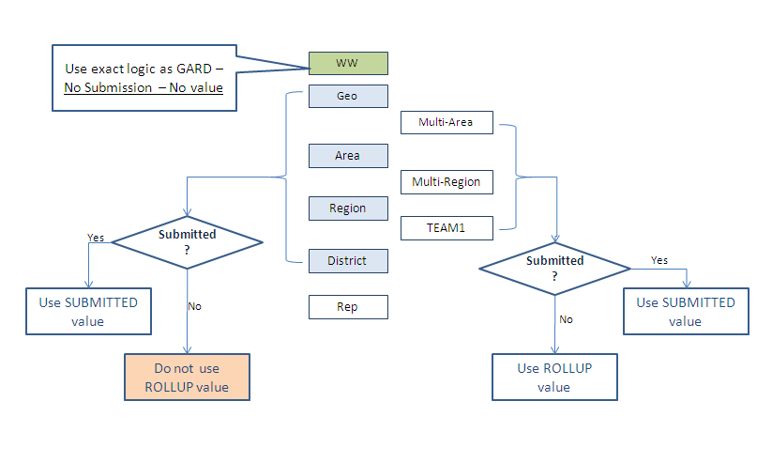

### *8 level Territory Hierarchy*

Worldwide

|

Geo

|

Multi-Area

|

Area

|

Multi-Region

|

Region

|

District

|

Team

|

Sales Rep

## House Account

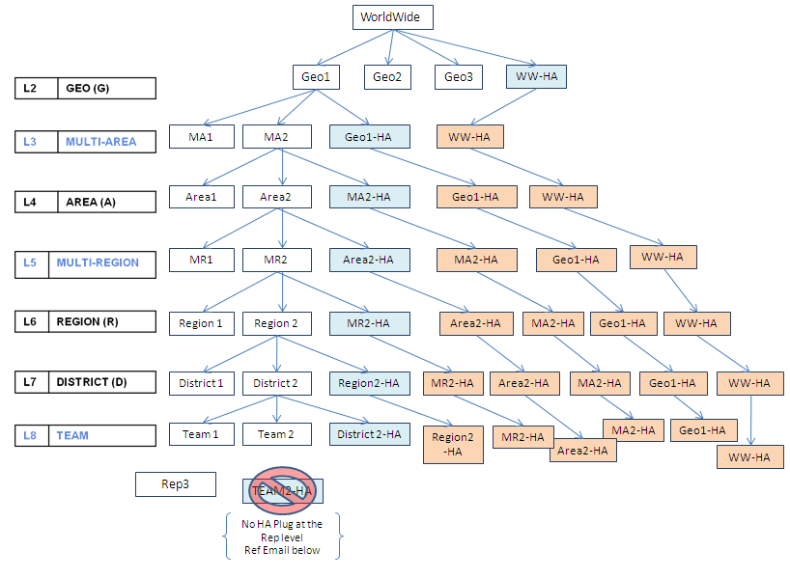

**HA Plug for any Made_On and Made_for combination = Parent forecast – sum (child forecast)**

The HA plug for each level will occur at one level below the parent down till the TEAM level. There is no HA Plug for the TEAM level. For e.g., the HA Account for the WW level will be at the GEO level, the HA Account for GEO will be at the Multi-Area level and so on.

In addition to computing the HA amount for each node [WW, GEO, MA, A, MR, R and D], each HA account will have corresponding nodes at each level. The same HA amount needs to be populated across all the nodes rolling up to the HA account until the TEAM level.

### *House Account Calculation Example*

* Submitted Forecast from Siebel at Region Level

|  |  |  |  |  |
| --- | --- | --- | --- | --- |
| 1. **REGION** | 1. **MADE FOR DATE** | 1. **MADE ON DATE** | 1. **FILER_AMT** | 1. **SOURCE SYSTEM** |
| 1. R1 | 1. JAN FY10 | 1. DEC 22 2009 | 1. 100 | 1. SIEBEL |
| 1. R2 | JAN FY10 | DEC 22 2009 | 1. 100 | 1. SIEBEL |
| 1. R3 | JAN FY10 | DEC 22 2009 | 1. 100 | 1. SIEBEL |

* District Level Forecast from Siebel

|  |  |  |  |  |
| --- | --- | --- | --- | --- |
| 1. DISTRICT | 1. MADE FOR DATE | 1. MADE ON DATE | 1. FILER AMT | 1. SOURCE |
| 1. D11 | 1. JAN FY10 | 1. DEC 22 2009 | 1. 35 | 1. SIEBEL |
| 1. D12 | 1. JAN FY10 | 1. DEC 22 2009 | 1. 35 | 1. SIEBEL |
| 1. D21 | 1. JAN FY10 | 1. DEC 22 2009 | 1. 45 | 1. SIEBEL |
| 1. D22 | 1. JAN FY10 | 1. DEC 22 2009 | 1. 45 | 1. SIEBEL |
| 1. D30 | 1. JAN FY10 | 1. DEC 22 2009 | 1. 90 | 1. SIEBEL |

* Region Level Forecast Rolled up from District level (B)

|  |  |  |  |  |
| --- | --- | --- | --- | --- |
| 1. REGION | 1. MADE FOR DATE | 1. MADE ON DATE | 1. FILER AMT | 1. SOURCE |
| 1. R1 | 1. JAN FY10 | 1. DEC 22 2009 | 1. 70 | 1. SIEBEL |
| 1. R2 | 1. JAN FY10 | 1. DEC 22 2009 | 1. 90 | 1. SIEBEL |
| 1. R3 | 1. JAN FY10 | 1. DEC 22 2009 | 1. 90 | 1. SIEBEL |

1. For Same Region, Made For Date, Made On Date, Subtract Filer AMT between (A) and (C)

|  |  |  |  |  |
| --- | --- | --- | --- | --- |
| 1. REGION | 1. MADE FOR DATE | 1. MADE ON DATE | 1. FILER AMT DIFERENCE | 1. SOURCE |
| 1. R1 | 1. JAN FY10 | 1. DEC 22 2009 | 1. 30 | 1. EDWNI |
| 1. R2 | 1. JAN FY10 | 1. DEC 22 2009 | 1. 10 | 1. EDWNI |
| 1. R3 | 1. JAN FY10 | 1. DEC 22 2009 | 1. 10 | 1. EDWNI |

E. Create Lookup between Region House Account (District Level) and Region

|  |  |
| --- | --- |
| 1. Region House Acct ( District Level) | 1. Region |
| 1. R1 HA | 1. R1 |
| 1. R2 HA | 1. R2 |
| 1. R3 HA | 1. R3 |

F. Lookup (D) with E with Region as lookup key column and Assign Filer Amount Difference to Region House Account (District Level) and load to table

|  |  |  |  |  |
| --- | --- | --- | --- | --- |
| DISTRICT | MADE FOR DATE | MADE ON DATE | FILER AMT DIFERENCE | SOURCE |
| R1 HA | JAN FY10 | DEC 22 2009 | 30 | SIEBEL |
| R2 HA | JAN FY10 | DEC 22 2009 | 10 | SIEBEL |
| R3 HA | JAN FY10 | DEC 22 2009 | 10 | SIEBEL |

## Valid Forecast Flag

There exists a column VALID_FORECAST_FLAG in the Fact tables.

For any given combination of (MADE_FOR_START_DATE_KEY, MADE_FOR_PERIOD_CODE, TERRITORY_KEY and TERRITORY_NODE_TYPE_CODE), there will be only one record with VALID_FORECAST_FLAG as ‘Y’ and i.e. record which is having **maximum** MADE_ON_DATE_KEY. Rest of the records will have value as ‘N’.

To incorporate above logic, there exists a job which runs at the end of the load.

The job aggregates data on the entire table using the condition (MADE_FOR_START_DATE_KEY, MADE_FOR_PERIOD_CODE, TERRITORY_KEY and TERRITORY_NODE_TYPE_CODE) and sets VALID_FORECAST_FLAG as ‘Y’ for **max**(MADE_ON_DATE_KEY).

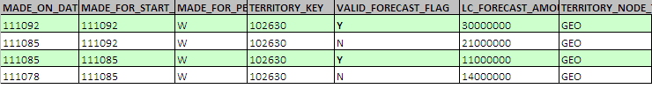

## Job Details

### *Incremental Load*

***Sequence Name*** – jsSiebelSalesForecast

***Master Sequence Name*** – msParent01

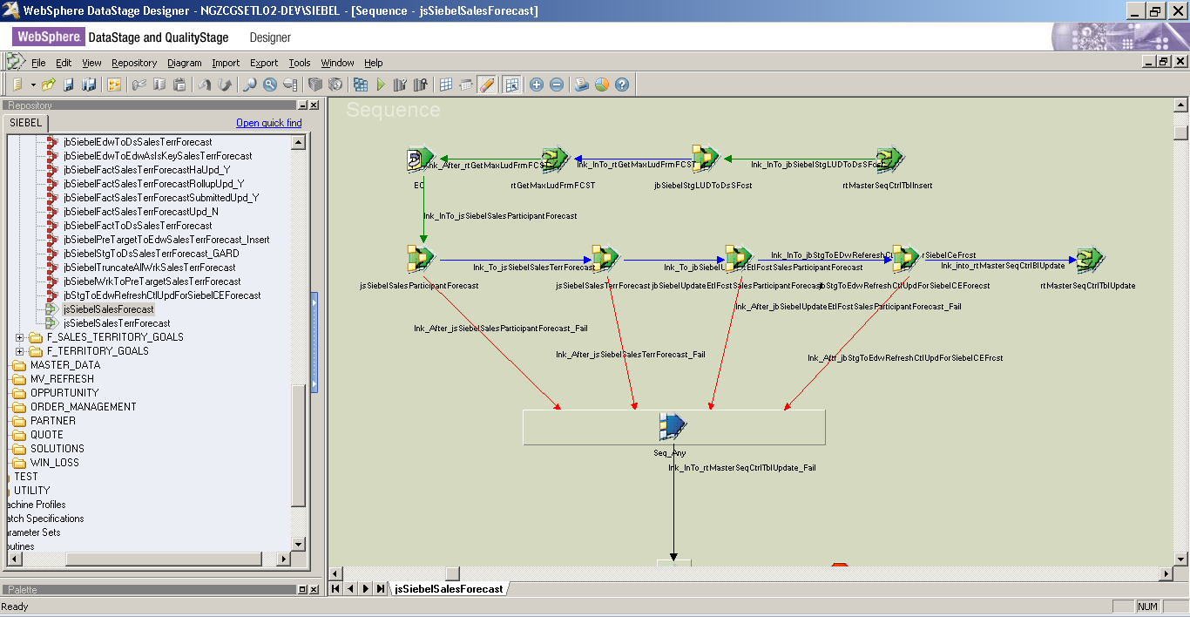

***jsSiebelSalesParticipantForecast –*** Participant forecast sequence

1. ***jbSiebelTruncateWrkSalesParticipantForecast*** – This job truncates Work table WORK.WRK_SALES_PRTCPT_FORECAST.
2. ***jbSiebelStgToWrkSalesParticipantForecast –*** This job fetches data from the staging tables, transform the data according to business logic and load it in WORK.WRK_SALES_PRTCPT_FORECAST table.

Source query –



Some of the important stages are as follows:

***Lookup_66*** – Any weekly forecast record which is having Made_For_Date < 2 weeks or monthly forecast record with Made_For_Date < 1 month is not propagated further in the next stage and gets captured in the exception table ETL.SIEBEL_FORECAST_EXCEPTION with an exception reason as 'Elapsed Made For Period'.

***Lkp_Week*** – MADE_ON_DATE_KEY for Weekly records are derived by matching Fiscal_Period (from source) with FISCAL_PERIOD_WEEK (derived using below query).

SELECT DATE_KEY, FISCAL_MONTH_START_DATE, FISCAL_WEEK_START_DATE, FISCAL_MONTH_LONG_TEXT, FISCAL_WEEK_LONG_TEXT, FISCAL_YEAR_SHORT_TEXT, FISCAL_MONTH_SHORT_TEXT, FISCAL_MONTH_WEEK_TEXT,

UPPER('W'||FISCAL_WEEK_OF_MONTH_NUMBER||' '||FISCAL_MONTH_SHORT_TEXT||' '||FISCAL_YEAR_SHORT_TEXT) AS FISCAL_PERIOD_WEEK

FROM DIMS.CALENDAR

WHERE FISCAL_MONTH_LONG_TEXT IS NOT NULL AND FISCAL_WEEK_START_DATE=BK_CALENDAR_DATE

AND TRUNC(BK_CALENDAR_DATE) >= '25-APR-2009'

***Lkp_Month*** – MADE_ON_DATE_KEY for Monthly records are derived by matching Fiscal_Period (from source) with FISCAL_PERIOD_MONTH (derived using below query).

SELECT DATE_KEY, FISCAL_MONTH_START_DATE, FISCAL_WEEK_START_DATE, FISCAL_MONTH_LONG_TEXT, FISCAL_WEEK_LONG_TEXT, FISCAL_YEAR_SHORT_TEXT, FISCAL_MONTH_SHORT_TEXT, FISCAL_MONTH_WEEK_TEXT,

UPPER('W'||FISCAL_WEEK_OF_MONTH_NUMBER||' '||FISCAL_MONTH_SHORT_TEXT||' '||FISCAL_YEAR_SHORT_TEXT) AS FISCAL_PERIOD_WEEK,

UPPER(FISCAL_MONTH_SHORT_TEXT||' '||FISCAL_YEAR_SHORT_TEXT) AS FISCAL_PERIOD_MONTH

FROM DIMS.CALENDAR

WHERE FISCAL_MONTH_LONG_TEXT IS NOT NULL AND FISCAL_MONTH_START_DATE=BK_CALENDAR_DATE

AND TRUNC(BK_CALENDAR_DATE) >= '25-APR-2009'

***tfm_system* –** Any Sales Participant with Position as ‘DEVELOPER’ does not get propagated further and gets captured in the exception table with exception reason as'Positon like DEVELOPER'.

***Lookup_Login_SalesParticipant_Tv –*** SALES_PARTICIPANT_AT_TRX_KEY is derived by matching Login (from source) with EMP_SYS_LOGIN_ID (using below query). TERRITORY_KEY is also derived here but it is not propagated till the Fact table. It is only loaded in Work table for internal calculation.

SELECT a.SALES_PARTICIPANT_KEY AS SALES_PARTICIPANT_AT_TRX_KEY,

upper(trim(a.EMP_SYS_LOGIN_ID)) AS LOGIN, a.TERRITORY_KEY, b.TEAM_CODE,

CASE WHEN (b.TEAM_CODE = 'ZZ') THEN -999999

WHEN (upper(b.WORLDWIDE_DESCRIPTION) <> upper('WW Direct Sales')) THEN -999999

WHEN (substr(b.TEAM_DESCRIPTION,-3) = ' HA') THEN -999999

ELSE b.TEAM_KEY

END TEAM_KEY

FROM DIMS.SALES_PARTICIPANT_TV a,

DIMS.SALES_TERRITORY_HIERARCHY b

where a.TERRITORY_KEY = b.TERRITORY_KEY

and a.current_record_flag = 'Y'

and trunc(a.start_date) <> nvl(trunc(a.end_date),'30-APR-2050')

and upper(a.participant_level_code) <> 'HA'

***Lookup_Login_Sales_Participant*** – SALES_PARTICIPANT_AS_IS_KEY is derived by matching Login (from source) with EMP_SYS_LOGIN_ID (using below query).

select max(SALES_PARTICIPANT_KEY) as SALES_PARTICIPANT_AS_IS_KEY,

upper(EMP_SYS_LOGIN_ID) AS LOGIN

from DIMS.SALES_PARTICIPANT

where current_record_flag='Y'

and EMP_SYS_LOGIN_ID is not null and EMP_SYS_LOGIN_ID not in ('NULL','null')

and PARTICIPANT_LEVEL_CODE <> 'HA'

group by upper(EMP_SYS_LOGIN_ID)

***Lookup_BkCalDate –*** MADE_FOR_START_DATE_KEY is derived in this stage by matching Made_For_Date (from source) with BK_CALENDAR_DATE (using below query).

select FISCAL_WEEK_START_DATE, FISCAL_MONTH_START_DATE, BK_CALENDAR_DATE, DATE_KEY from DIMS.CALENDAR where trunc(BK_CALENDAR_DATE)>'1-Jan-2008'

***Lkp_CurrConv_ME –*** Fact table has three different types of amount columns.

LC_FORECAST_AMOUNT – stores forecast in local currency amount.

* + If LC_FORECAST_AMOUNT is in USD, then both ME_FORECAST_AMOUNT and BE_FORECAST_AMOUNT are same as LC_FORECAST_AMOUNT.
  + If LC_FORECAST_AMOUNT is non-USD, then both ME_FORECAST_AMOUNT and BE_FORECAST_AMOUNT are converted to USD based on ME rate and BE rate respectively.

In this stage ME_FORECAST_AMOUNT is calculated using below logic -

1. Lookup DIMS.CURRENCY_CONVERSION_RATE using FROM_CURRENCY = Func_Currency (from source) and TO_CURRENCY = 'USD' and BK_START_DATE = Made_On_Date and Rate_Type = 'CORPORATE' to get the conversion rate.

2. Multiply LC_FORECAST_AMT with the conversion rate.

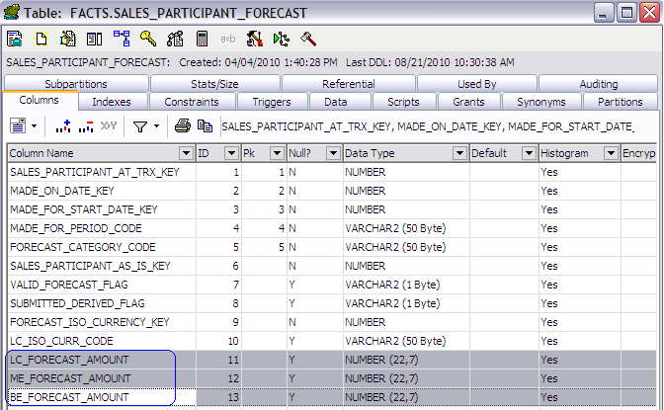

***Lkp_CurrConv_BE –*** In this stage BE_FORECAST_AMOUNT is calculated using below logic –

1. Lookup DIMS.CURRENCY_CONVERSION_RATE using FROM_CURRENCY = Func_Currency (from source) and TO_CURRENCY = 'USD' and Made_On_Date between (BK_START_DATE and BK_END_DATE) and Rate_Type = 'BUDGETED' to get the conversion rate.

2. Multiply LC_FORECAST_AMT with the conversion rate.

*P.N – All the records loaded in Work Table will have VALID_FORECAST_FLAG as ‘Y’ and DERIVED_FLAG as ‘N’.*

1. ***jbSiebelWorkToDsSalesParticipatForecast –*** This job loads data from Work table into a dataset “Wrk_Sales_Participant_Forecast_Incr_Replica.ds”.
2. ***jbSiebelSblFactToWrkSalesParticipantForecast –*** This job brings back processed records for a certain period in Work table from Fact table to maintain consistency in data for internal calculation (i.e. Rollup).

Some of the important stages are as follows:

***Facts_Sales_Participant_Forecast –*** Below query is used to retrieve records from Fact table for a certain period -

select a.* from (select * from facts.sales_participant_forecast where made_for_start_date_key in

(select date_key from dims.calendar where

**fiscal_months_back < 1** and fiscal_month_start_date = bk_calendar_date) and made_for_period_code = 'M'

and SUBMITTED_DERIVED_FLAG = 'S'

UNION

/* WEEKLY FORECAST FROM FACTS - ALL WEEKS AFTER & INCLUDING PREVIOUS WEEK */

select * from facts.sales_participant_forecast where made_for_start_date_key in

(select date_key from dims.calendar where

**fiscal_weeks_back < 2** and fiscal_week_start_date = bk_calendar_date) and made_for_period_code = 'W'

and SUBMITTED_DERIVED_FLAG = 'S') a, dims.source_system b

where a.source_system_key = b.source_system_key and upper(b.source_system_name)= 'SIEBEL'

***Lookup_Wrk –*** In this lookup stage, data from input link is matched with the recently loaded dataset “Wrk_Sales_Participant_Forecast_Incr_Replica.ds” and only rejected records are carried forward and loaded in Work table.

*P.N – All the records loaded in Work Table will DERIVED_FLAG as ‘P’ to indicate they are already processed records.*

1. ***jbSiebelWrkToEdwSalesParticipantForecast_Insert –*** This job loads data from Work table into the Fact table.
2. ***jbSiebelSalesParticipantForecastUPD_N –*** This job updates VALID_FORECAST_FLAG with value ‘N’ for all records.
3. ***jbSiebelSalesParticipantForecastUPD_Y –*** This job updates only VALID_FORECAST_FLAG column as per below logic -

For a given period i.e. (MADE_FOR_START_DATE_KEY, MADE_FOR_PERIOD_CODE combination) and a particular SALES_PARTICIPANT_AT_TRX_KEY, there can be only one record with VALID_FORECAST_FLAG as 'Y' which is having **maximum** MADE_ON_DATE_KEY.

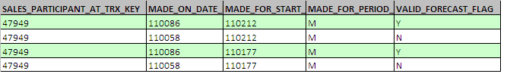

## Appendix

### *Table Structure*

FACTS.SALES_PARTICIPANT_FORECAST –

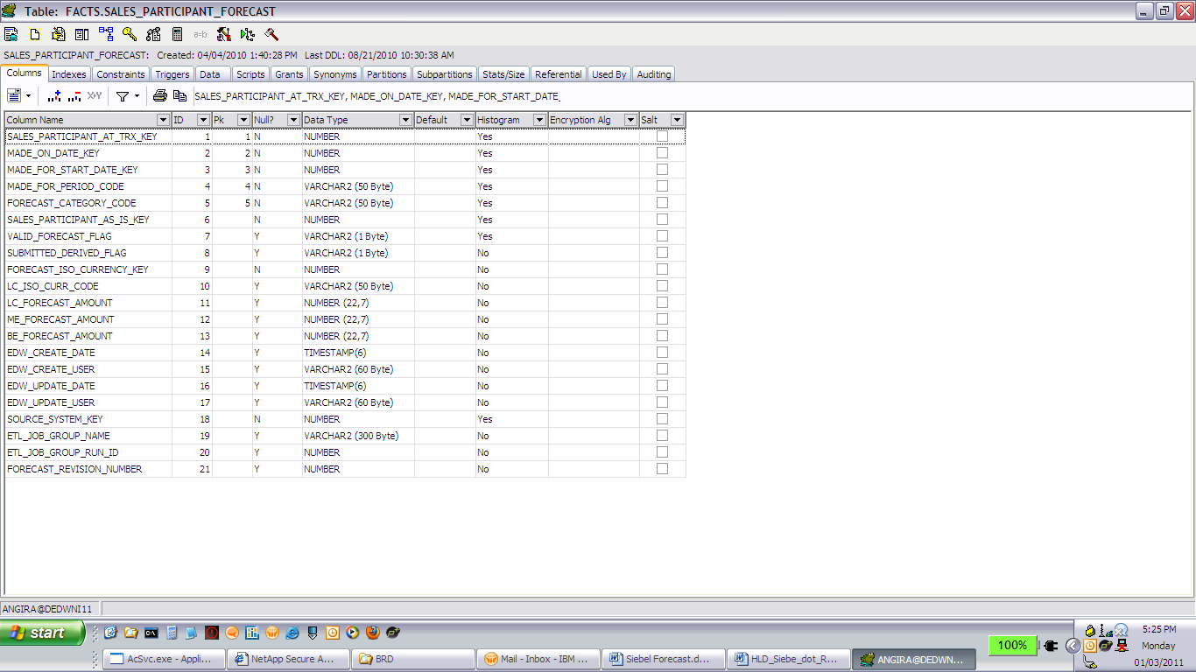

### FACTS.SALES_TERRITORY_FORECAST_SB –

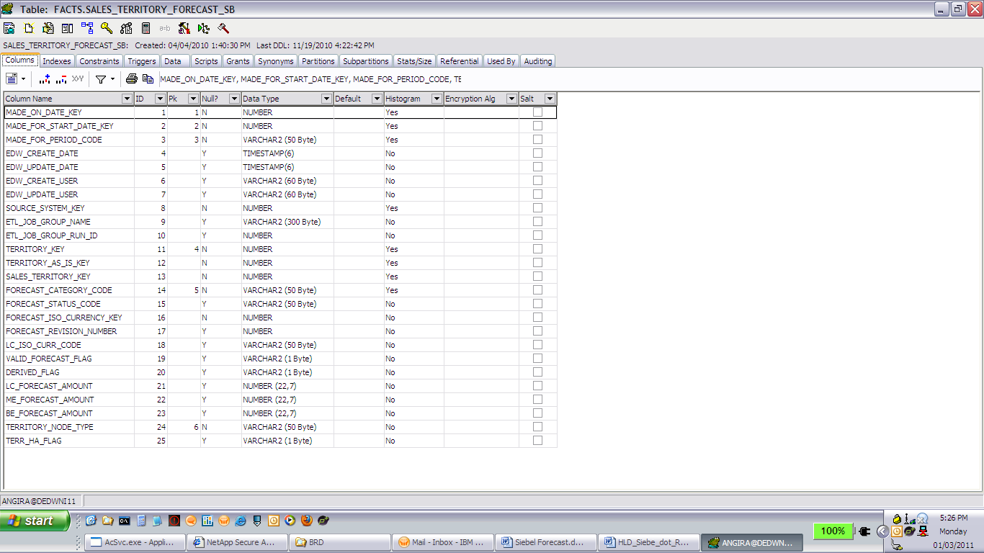

### *References*

High Level ETL Data Flow Document – Siebel CE Forecasting by Ramesh Raghothama



High Level Document - Siebel Dot Release by Raman Naren

